Disaster Recovery is a service in which azure keeps a copy of your Vm in Different location to tackle unpredictable natural calamities , War and Datacenter crash .

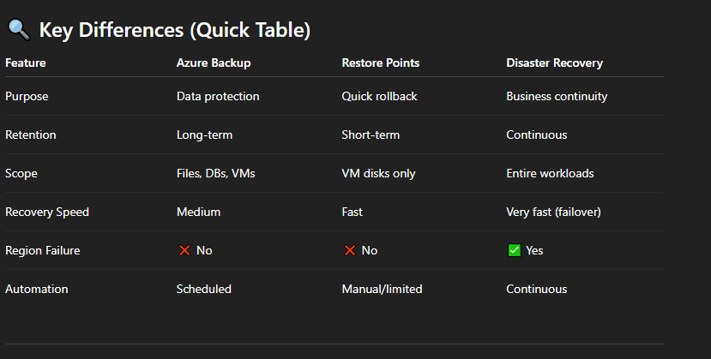

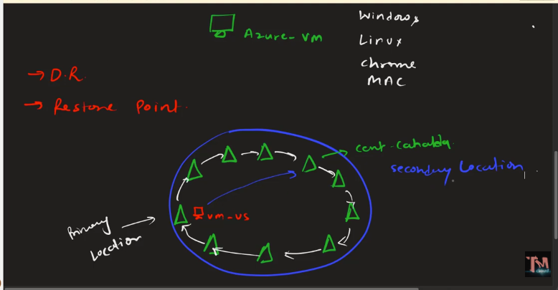

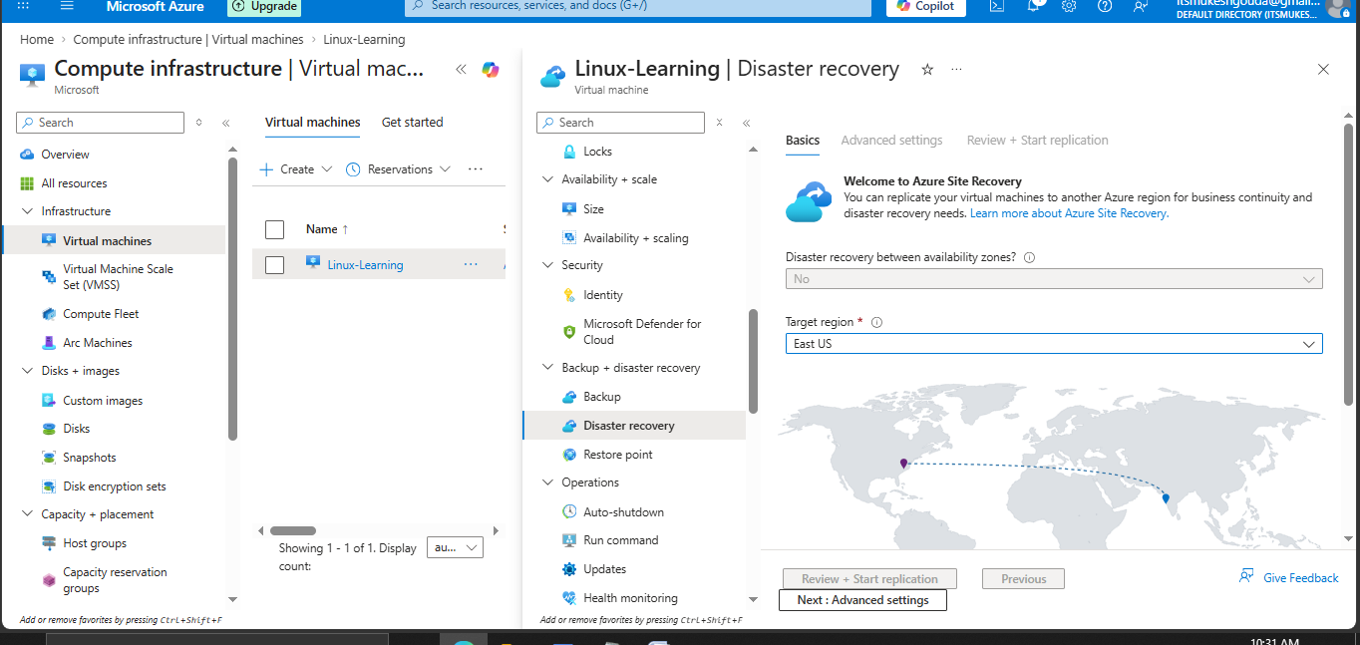
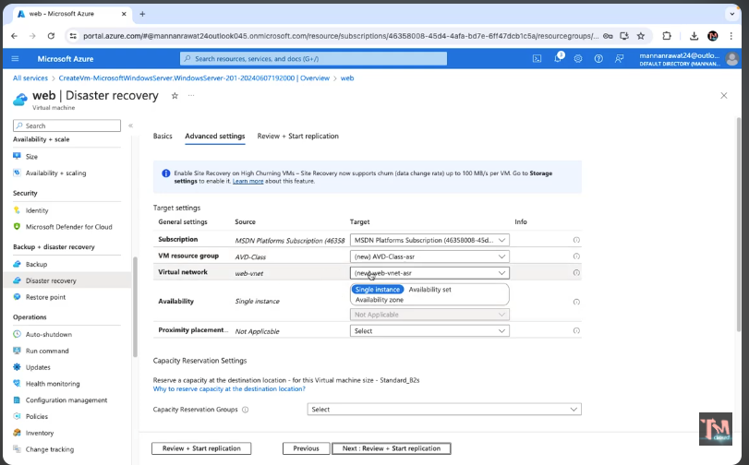

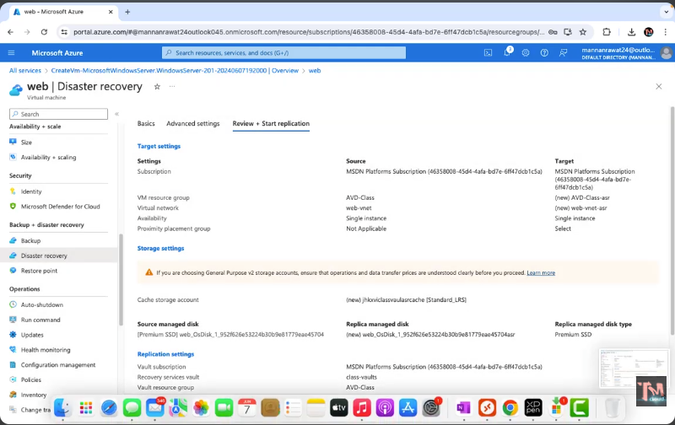
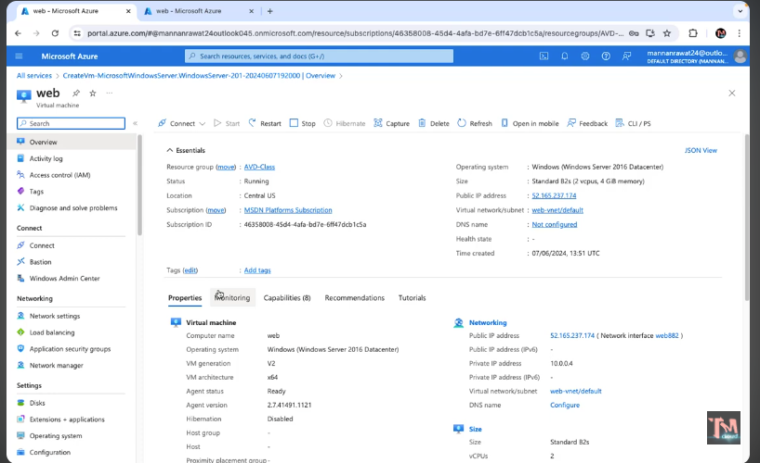
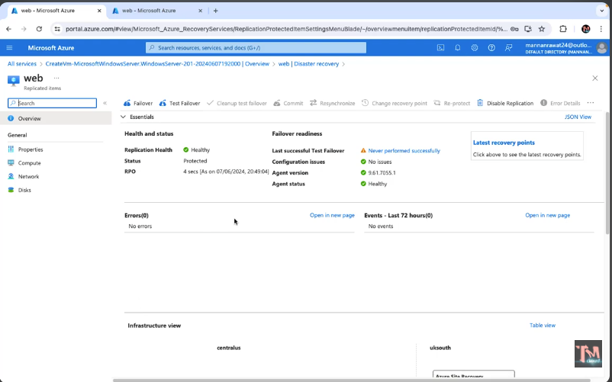

Failover – the actual failover where the service will redirect from failed location to backup Vm location
Test filover – it’s a simulation of failover to test the fialover

